**Future of Trading: Algo-Trading**

Author:- Tejas Vitthal Adhude

10 Feb. 24

**1.PROBLEM STATEMENT**

The financial market is one of the foundations of any nation. A lot of new traders and investors are observed in the stock market from the Corona; many of them have little to no experience, which causes losses in the market. The main reason for the losses in stock market is Greed/Fear, Emotions.

Numerous businesses manage a large number of clients' money. As the number of publicly traded companies rises, it could become more challenging to analyze each one individually and Make the finest trading decision possible.

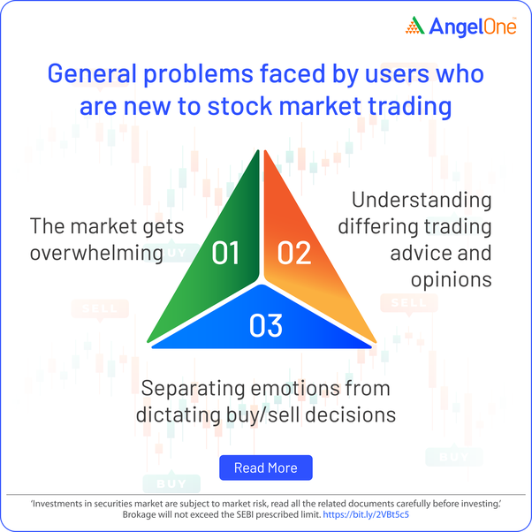

**2.MARKET/CUSTOMER/BUSINESS NEED ASSESSMENT**

**Market**

* As of October 30, 2023, the National Stock Exchange (NSE) has 80 million direct investors in the Indian stock market. This is about 17% of all Indian households, or around 50 million households.
* In the U.S. equity market, European financial markets, and major Asian capital markets, algorithmic trading accounts for about 60-75 percent of the overall trading volume. Algo trading has been on the rise in the U.S. equity markets since the turn of the century but seems to have plateaued around 70-80 percent in the last 5 to 10 years.
* The overall trading volume of algorithmic trading in emerging economies like India is estimated to be around 40 percent.

**Customer**

* Institutional investors use numerous computer-driven algorithmic strategies to execute and manage their orders. These techniques enable them to cut down the costs of trades and improve their profitability. Algorithmic trading is particularly helpful for high order sizes, which is why institutional investors and large brokerage firms largely make use of it to reduce trading expenses

**Business Need**

1. Reduce Latency:- Algorithmic trading can execute trades at speeds much faster than manual trading.
2. Automated Risk Control:- Automatically monitoring and managing risk according to predefined rules.
3. Data Analysis:- Algorithmic systems can process vast amounts of market data, news, and other information.
4. Historic Analysis:- Enables traders to use past market data to back test strategies.
5. Scalability:- Automated systems can handle a larger number of trades and markets simultaneously.
6. Operational Efficiency:- Automation reduces the need for manual intervention, cutting down on human resources and operational costs associated with trading activities.

**3.TARGET SPECIFICATIONS AND CHARACTERIZATION**

**Identify the patterns in the market**

Utilize machine learning models to analyse historical market data and identify pattern, This information is then used to make predictions about future price movements.

Providing screening tool that recognize complex patterns in stock charts, such as head and shoulders, double tops, and triangles. Pattern recognition is one of the important for technical analysis.

**News and Events Analysis**

When any news flows in market, the Technical Analysis tends to Fail.

Analyse financial news articles, social media, and other textual data to gauge market sentiment. Positive or negative sentiment can impact stock prices, and ML models can help quantify and analyse this sentiment.

**Balance Sheet Analysis**

Fundamental Analysis provide important role while taking decision for investment or long-term investment. Analysing Balance Sheet provides great insight about financial condition of the institute or company.

Analyse the financial Ratios ( Current ratio, Debt ratio etc.) derived from balance sheet which helps to evaluate companies performance.

predict future financial health and cash flows based on historical balance sheet data.

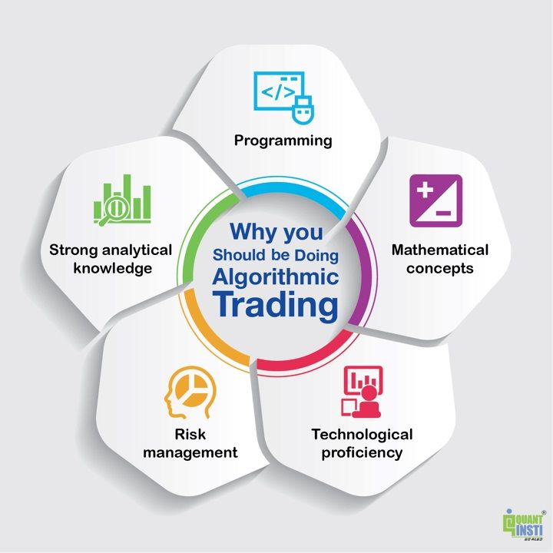

**4.EXTERNAL SEARCH**

* The Use of Artificial Intelligence in Algorithmic Trading in the Global Market

[*https://www.linkedin.com/pulse/use-artificial-intelligence-algorithmic-trading-alfred-olutola/*](https://www.linkedin.com/pulse/use-artificial-intelligence-algorithmic-trading-alfred-olutola/)

* Machine Learning in Trading

[*https://github.com/stefan-jansen/machine-learning-for-trading*](https://github.com/stefan-jansen/machine-learning-for-trading)

**Books:**

* Machine Learning for Algorithmic Trading, by Stefan Jansen.
* Algorithmic Trading: Winning Strategies and Their Rationale, by Ernest P. Chan.
* Machine Learning for Algorithmic Trading, by Stefan Jansen.

**Research Paper:**

* Algorithmic Trading of Futures via Machine Learning, by Bao, Lopez de Prado, and Meloso.
* Reinforcement Learning for Trading, by Aravindh Mahendran.

**5. APPLICABLE REGULATIONS**

* Prior Approval from Exchange is required by any member before implementing any algorithmic trading.
* For Audit purpose member may need to share the Strategy with SEBI.
* For Audit purpose member may need to share the Strategy with SEBI.
* All orders generated by an API should be classified as algo orders and subject to broker oversight.
* Each algo strategy has to be certified by Certified Information Systems Auditor (CISA)/ Diploma in Information System Audit (DISA) auditors.

**6. APPLICABLE CONSTRAINTS**

**Technology Infrastructure**

A robust and reliable technology infrastructure is essential. Technical issues, such as system failures or connectivity problems, can lead to significant financial losses. Ensuring redundancy, reliability, and low-latency systems is crucial .

**Market Impact and Liquidity**

Large trades can significantly impact market prices and liquidity. Any wrong or huge order can lead unexpected change in market / stock direction.

**Reliable Real Time and Historic Data**

The real time and Historic Data should be reliable. The quality, accuracy, and integrity of data should be ensured.

**Data Security and Privacy**

The sensitive data should be protected. The Security should be provided to safe the algorithm, trading strategies.

**7.BUSINESS MODEL**

* A brokerage firm specifically catering to algorithmic traders. Offer low-latency trading platforms, competitive fees, and access to various markets.
* Identify new trading strategies and opportunities. Offer research reports, insights, and consultancy services to institutional and retail clients.
* Provide tool like Balance sheet Analyser.
* Proving alerts for script when the selected pattern fount out.
* Show all available insight (balance sheet analysis, news-based trend etc) for given script.
* Provide training and educational services for individuals and organizations looking to understand and implement algorithmic trading strategies. This could include workshops, courses, and consulting services.
* Execution of orders on the basics of predefined rules and condition.

**8. Concept Generation**

Some of the common methodologies and algorithms are:

* **Trend-following strategies:**

These are strategies that aim to exploit the persistent movements of prices in a certain direction, based on indicators such as moving averages, channel breakouts, or price level movements. These strategies are relatively simple to implement and do not require any predictions or forecasts. [An example of a trend-following strategy is the moving average crossover, which generates buy and sell signals based on the crossing of two moving averages of different periods1](https://www.investopedia.com/articles/active-trading/101014/basics-algorithmic-trading-concepts-and-examples.asp).

* **Arbitrage strategies:**

These are strategies that aim to exploit the price differences or inefficiencies between two or more markets or instruments, such as stocks, futures, options, or currencies. These strategies require high-speed execution and low-latency data access, as the arbitrage opportunities may disappear quickly. [An example of an arbitrage strategy is the triangular arbitrage, which exploits the mispricing of three currency pairs that are related by a triangular relationship1](https://www.investopedia.com/articles/active-trading/101014/basics-algorithmic-trading-concepts-and-examples.asp).

* **Index fund rebalancing:**

This is a strategy that aims to capitalize on the price movements caused by the periodic rebalancing of index funds, which are funds that track the performance of a market index, such as the S&P 500. These funds need to adjust their holdings to match the changes in the index composition or weighting, which may create temporary imbalances in the supply and demand of the underlying stocks. [An example of an index fund rebalancing strategy is to buy or sell the stocks that are expected to be added or removed from the index before the rebalancing date1](https://www.investopedia.com/articles/active-trading/101014/basics-algorithmic-trading-concepts-and-examples.asp).

* **Volume-weighted average price (VWAP) strategy:**

This is a strategy that aims to execute a large order at the best possible price, while minimizing the market impact and the risk of adverse price movements. This strategy splits the order into smaller sub-orders and executes them according to the historical volume distribution of the market, which reflects the liquidity and activity of the market. [The goal is to match or beat the VWAP benchmark, which is the average price weighted by volume over a specified time period1](https://www.investopedia.com/articles/active-trading/101014/basics-algorithmic-trading-concepts-and-examples.asp).

* **Time-weighted average price (TWAP) strategy:**

This is a strategy that aims to execute a large order at a uniform rate, while minimizing the market impact and the risk of adverse price movements. This strategy splits the order into smaller sub-orders and executes them at regular intervals over a specified time period. [The goal is to match or beat the TWAP benchmark, which is the average price over a specified time period1](https://www.investopedia.com/articles/active-trading/101014/basics-algorithmic-trading-concepts-and-examples.asp).

**9.** **Concept Development**

**1. Defining the Trading Strategy:**

Define the logic and rules that the algorithm will follow. This could be based on technical analysis, fundamental analysis, quantitative models, or a combination of these.

**2. Data Collection and Analysis:**

Gather relevant data from various sources (historical price data, market news, economic indicators, etc.).Analyse the data to identify patterns, trends, correlations, or any other factors that can inform your trading strategy.

**3. Algorithm Development:**Build the algorithm based on your defined strategy. This might involve coding the logic in a programming language (e.g., Python, R, or a proprietary language if using a trading platform).Implement risk management techniques within the algorithm (e.g., stop-loss orders, position sizing, etc.).Use mathematical models or machine learning algorithms if appropriate for your strategy.

**4. Back Testing:**

Test the algorithm using historical data to assess its performance. This helps in evaluating how the algorithm would have performed in the past and in identifying potential flaws or areas for improvement.

**5. Optimization:**

Refine the algorithm based on the insights gained during back-testing. Adjust parameters, fine-tune strategies, and optimize the code to improve its performance.

**6. Paper Trading or Simulation:**

Implement the algorithm in a simulated or paper trading environment to see how it performs in real-time, but without using real money.

**7. Live Trading:**

Once satisfied with the results from paper trading, you can deploy the algorithm in live trading. Monitor its performance closely and be ready to make adjustments as needed.

**8. Continuous Monitoring and Improvement:**

Regularly monitor the algorithm's performance and make adjustments as market conditions or the strategy's effectiveness change.

**10.FINAL PRODUCT PROTOTYPE**

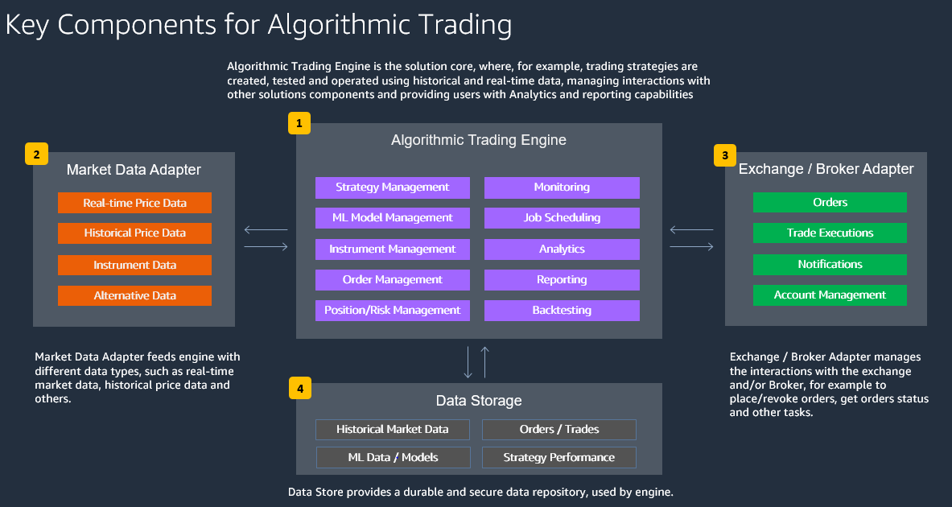

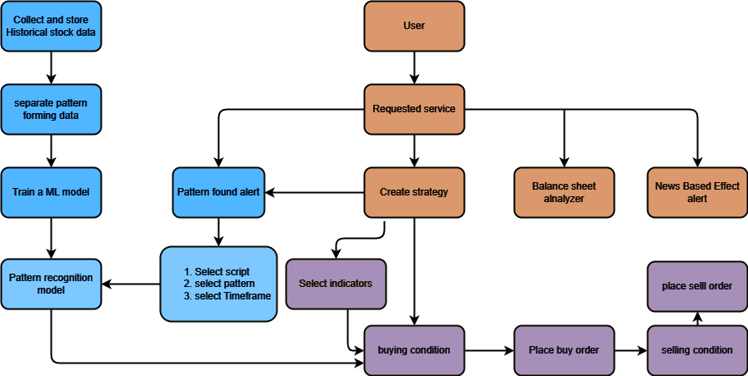

**Service flow**

**11. CONCLUSION**

Algorithmic trading, driven by automated systems and predefined rules, provides efficiency and speed in executing strategies across diverse markets. Its advantages include automation and reduced emotional bias, yet it demands expertise in computer science, finance, and mathematics. However, it's not a guaranteed solution and requires continuous monitoring, risk management, and adaptation to dynamic market conditions. While powerful, algorithmic trading is a tool that, when combined with a robust strategy and careful implementation, can potentially enhance trading outcomes.

**AI Product Service Prototype Development and Business/Financial Modelling**

**1.PROTOTYPE SELECTION**

**Prototype Idea:**

**AI-Powered Stock Market Prediction Platform.**

**a. Feasibility:**

**This prototype is feasible for short-term development as the necessary technologies, such as machine learning algorithms for predictive analysis, are readily available. With the rapid advancements in AI and data analysis techniques, developing a stock market pattern prediction platform within the next 2-3 years is achievable.**

**b. Viability:**

**The stock market is an integral part of the global economy, and its relevance is expected to persist in the long term (20-30 years). Therefore, an AI-powered stock market pattern prediction platform remains viable as long as financial markets continue to operate.**

**c. Monetization:**

**The platform can be directly monetized through subscription-based models, licensing fees for access to predictive algorithms, and potentially through partnerships with financial institutions for exclusive insights.**

**2.PROTOTYPE DEVELOPMENT**

GitHub Link: <https://github.com/tejas-adhude/feynn-labs/tree/main/Task2>

**3.BUSINESS MODELLING**

Key Partners: Data providers, financial institutions, AI technology providers.Key Activities: Data collection, algorithm development, platform maintenance.Key Resources: AI algorithms, historical market data, software development team.Value Proposition: Accurate stock market predictions, informed investment decisions.Customer Segments: Retail investors, financial advisors, institutional investors.Channels: Online platform, API integrations with financial software.Customer Relationships: Automated predictions, customer support.Revenue Streams: Subscription fees, licensing fees, partnership agreements.Cost Structure: Data acquisition costs, development costs, operational costs.

* A brokerage firm specifically catering to algorithmic traders. Offer low-latency trading platforms, competitive fees, and access to various markets.
* Identify new trading strategies and opportunities. Offer research reports, insights, and consultancy services to institutional and retail clients.
* Provide tool like Balance sheet Analyser.
* Proving alerts for script when the selected pattern fount out.
* Show all available insight (balance sheet analysis, news-based trend etc) for given script.
* Provide training and educational services for individuals and organizations looking to understand and implement algorithmic trading strategies. This could include workshops, courses, and consulting services.
* Execution of orders on the basics of predefined rules and condition.

**4.FINANCIAL MODELLING**

Algo-trade has covered up the maximum place in the stock market. In India, the percentage of traders who use algorithms for trading ranges from 50 to 55 per cent. But in other markets, the percentage of algo-trading is around 80–85% of trade.

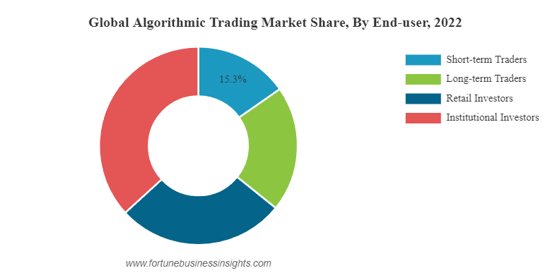

Global Algorithamic Trading Market (2022-2030) USD Billion

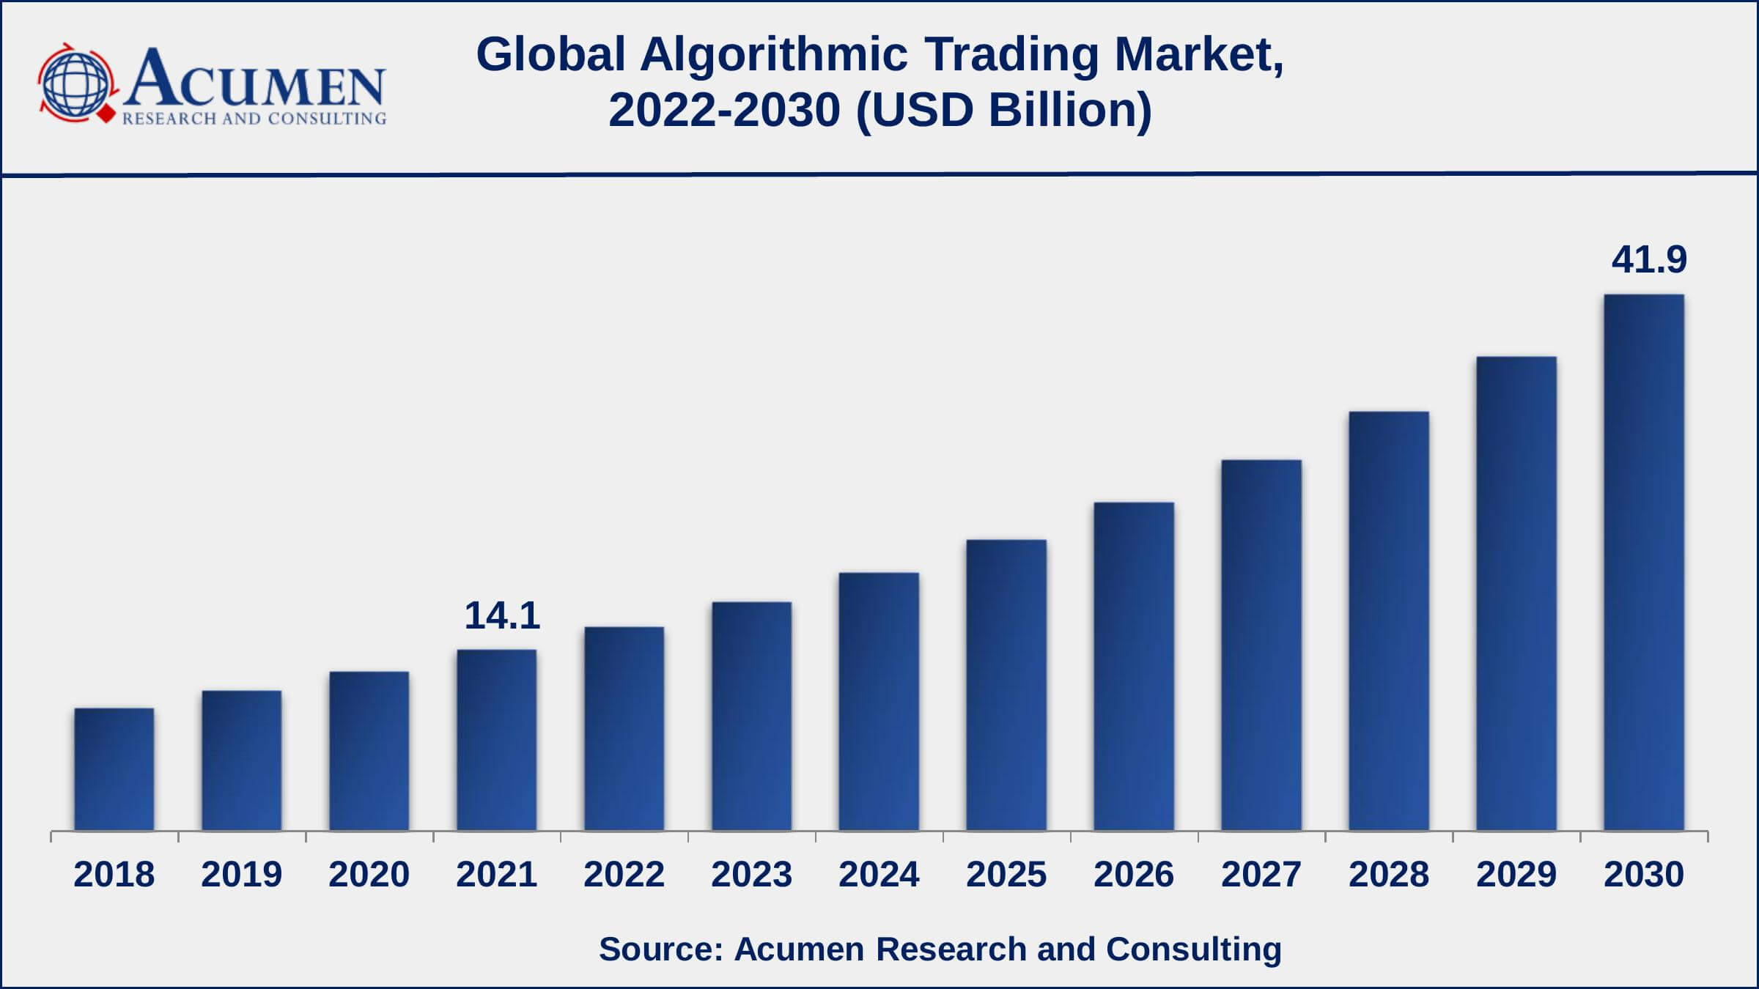

The financial equation typically revolves around the profitability of trading strategies executed by algorithms.

Profit=(Winning Trades×Average Profit per Trade)−(Losing Trades×Average Loss per Trade)−Trading Costs

*Winning Trades* is the number of trades that resulted in a profit.*Average Profit per Trade* is the average profit gained from each winning trade.*Losing Trades* is the number of trades that resulted in a loss.*Average Loss per Trade* is the average loss incurred from each losing trade.*Trading Costs* include transaction fees, commissions, slippage, and any other costs associated with executing trades.